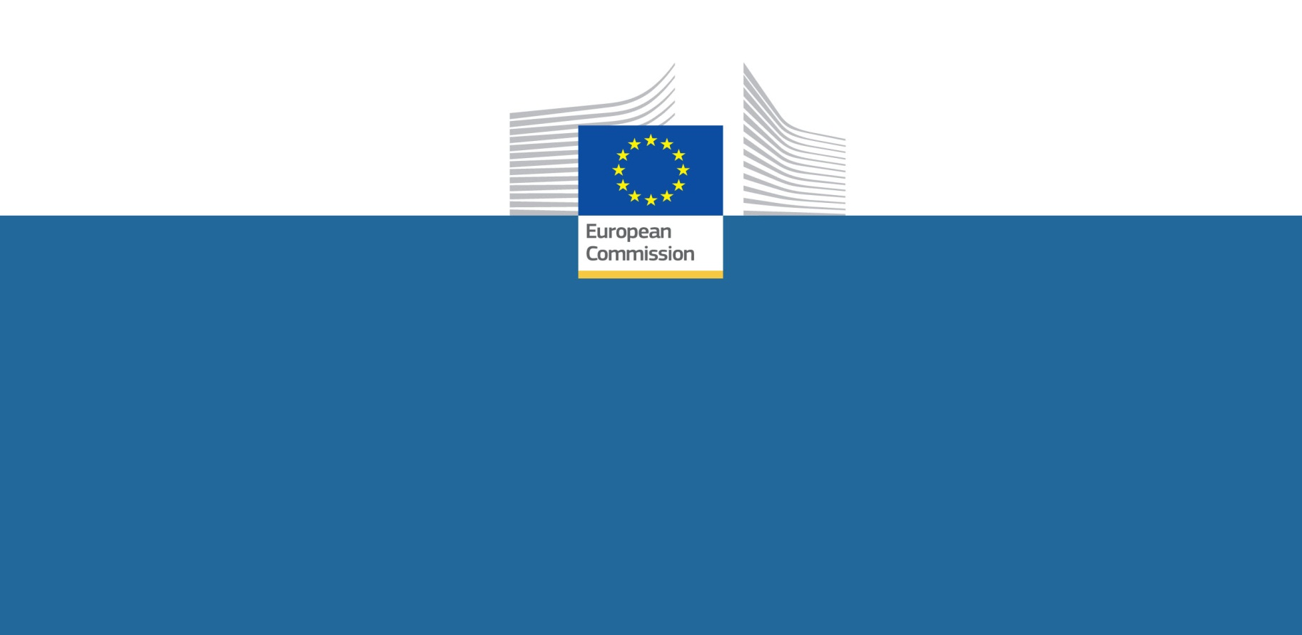

Erasmus+

Worldwide opportunities for   
higher education cooperation

**Erasmus+ is the EU's new programme for education, training youth and sport for the period 2014-2020. It will offer a number of opportunities for higher education students, researchers, staff and institutions from across the world. All these opportunities are funded by the European Union.**

**Worldwide opportunities for higher education institutions**

**Joint master degree programmes**

Your university can be part of a consortium of higher education institutions that offers a **Joint Master Degree** programme. These high-level programmes are selected by the European Commission under annual Calls for Proposals. All consortium members design and offer the programme together, and students will study or research in at least two of the institutions. Your institution will therefore be involved in delivering the courses and selecting and hosting the students. The consortium awards a joint or double/multiple degree at the end of the studies. Students apply directly to the consortium, which carries out a competitive selection procedure for EU-funded scholarship places.

* + *Institutions from Erasmus+ countries* will be able to submit an application to manage a joint Masters programme under an* Erasmus+ *Call for Proposals. Higher education institutions from other countries across the world can be partners in the consortium.*

**Joint doctoral programmes**

Your university can be involved as a partner in a consortium of higher education institutions that offers a **European Joint Doctorate** under the Marie Skłodowska-Curie Actions.

* + *Visit the website of the* Marie Skłodowska-Curie Actions *for more information.*

**Higher education inter-institutional agreements for credit mobility**

By concluding an inter-institutional agreement with another university, your university will be able to send your own students, doctoral candidates or staff (with scholarships) for short-term mobility (up to 12 months) to partner universities covered by the agreement anywhere in the world. Under the agreement your institution will recognise the credits accrued by your students when abroad, which will contribute to the student's degree once back home. Your staff will be able to receive grants for teaching assignments or training at the partner institution. Under the same agreement, you will be able to host foreign students, PhD candidates or staff for similar short-term study periods at your institution.

* + *Institutions from Erasmus+ countries* will be able to submit an application to manage a mobility project for higher education students, PhD candidates and staff. This should be submitted to the National Agency for Erasmus+ of their country. Higher education institutions from other countries across the world can be part of the inter-institutional agreement.*

**Capacity-building projects**

Your university can take part in collaborative **capacity-building projects** set up and managed by a consortium of universities from the Erasmus+ countries* on the one hand and those from a particular region of the world on the other (the EU's neighbouring countries, candidate and potential candidate countries, Latin America, Asia, Africa-Caribbean-Pacific countries). These projects can be:

* Joint projects: these help all partners to develop, modernise and disseminate new curricula, teaching methods or materials, as well as to boost quality assurance and governance of higher education institutions.
* Structural Projects: to develop and reform higher education institutions and systems; to enhance their quality and relevance, promote regional cooperation and increase convergence.



In certain partner countries neighbouring the EU, capacity-building projects will also be able to include a mobility component targeted at students and staff from the institutions involved in the project.

* + *Institutions from all over the world can submit a proposal for a capacity-building project under an* Erasmus+ *Call for Proposals.*

**Strategic Partnerships and Knowledge Alliances**

Institutions from partner countries can equally participate in strategic partnerships and Knowledge Alliances.[1]

**Jean Monnet projects**

Your university can propose a project specialised in EU studies to promote excellence in teaching and research on the European integration process. The Jean Monnet programme supports these projects and the professors, while key activities include courses, research, conferences, and publications in the field of EU studies.

* + *Institutions and associations from all over the world will be able submit a proposal for a Jean Monnet project under an* Erasmus+ *Call for Proposals. Jean Monnet projects involve a unilateral agreement between the Agency and only one beneficiary institution. However, in practice, and particularly in the case of networks, the informal involvement of partner institutions is possible.*

**Opportunities for individuals**

**Students/young researchers**

* You can apply for a masters scholarship or a doctoral fellowship to follow one of the high-level **joint programmes** at masters or doctoral level selected by Erasmus+, and offered by a consortium of universities. You will study in at least two of the universities and be awarded a joint or double/multiple degree at the end of your studies.
  + *Apply directly to the consortium, which carries out a competitive selection procedure for scholarship places, open to candidates from across the world.*
* If your university has an inter-institutional agreement with a partner university you can apply for a grant for short-term **credit mobility** (up to 12 months), under which you can spend part of your study period (at bachelors, masters or doctorate level) at that partner institution. The course(s) you follow will provide you with credits that will be recognised and contribute to your degree back home.
  + *Contact your institution's international office for more information.*
* You can apply for doctoral and post-doctoral fellowships and other research grants available under the Marie Skłodowska-Curie Actions, which form part of the EU's Horizon 2020 programme for research and innovation.
  + *Find out more on the Marie Skłodowska-Curie webpages.*

**Higher education institution staff**

If your university has an inter-institutional agreement with a partner university or is partner in a joint Master degree programme, you can apply for a grant to spend a period at this partner institution to deliver teaching or training, or to follow training for career development purposes.

* + *Contact your institution's international office for more information.*

*ERASMUS+*: **http://ec.europa.eu/dgs/education_culture/index_en.htm**

*MARIE Skłodowska-CURIE ACTIONS*: [**ec.europa.eu/mariecurieactions**](http://ec.europa.eu/mariecurieactions)

*\*Erasmus+ countries = the 28 EU countries plus other European countries. Check the Call for Proposals for more information.*

*The architecture of the new programmes will be finalised in the legal texts on the programme to be published in the fourth quarter of 2013.*

1. see Erasmus+ „What’s in it for higher education“ leaflet