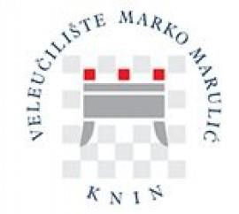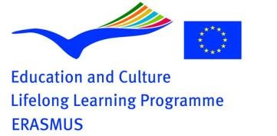

The University of Applied Sciences Marko Marulić in Knin
Kralja Petra Krešimira 30, 22300 Knin,
The Republic of Croatia
A Letter of Intent
This Letter of Intent strives to provide information to future partners about the relevant facts and activities of the University of Applied Sciences Marko Marulić in Knin within the Erasmus Lifelong Learning Programme. We are indeed interested in co-operating with higher education institutions (HEIs) of similar study programmes, as well as educational and scientific interests, in accordance with the principles of the Erasmus Programme.
The University of Applied Sciences Marko Marulić in Knin (UASMMK) is a relatively young, higher education institution, founded in June 2005. It was incepted as an institution with the primary task of education of students through the professional studies (five study programmes – three departments): Karst Agriculture (Undergraduate Professional Study of Karst Agriculture – Plant Production and Undergraduate Professional Study of Karst Agriculture – Animal Husbandry), Undergraduate Professional Study of Food Technology and Undergraduate Professional Study of Commercial Business with Entrepreneurship and the Specialist Graduate Professional Study of Economics and Normative Frame of Entrepreneurship.
This programme concept is designed as a cycle that includes education in primary production (Karst Agriculture), processing (Food Technology) and trading (Economics) in which practical training of young Bachelors in progress is a very important activity, which will make them adequately trained for working in production soon after graduation, including application, implementation and use of the new modern technologies and scientific achievements in practice. Furthermore, there are on-going preparations for organisation of new study programmes at both undergraduate and graduate level.
Science and higher education are the most important factors of development in the world, hence the desire of the UASMMK is that our actions contribute to the rapid and high-quality development of the city of Knin and the surrounding area, the Šibenik-Knin County and beyond.
Compared with the graduates of other similar European and international institutions, our graduates are equally competent in their field, especially because our curricula are developed and implemented in accordance with the Bologna Process, approved by the competent authorities and are comparable with similar ones in Europe.
The UASMMK is a young institution that has not yet developed international co-operation to the desired level, which is understandable considering that we were established 15 years ago. Nevertheless, some of our professionals have established cooperation within the framework of individual projects in which they participate and many participated in various international conferences both in the country and abroad. The UASMMK participated in international projects and co-operated with various institutions from Europe.
Our quality system sets down norms and procedures to ensure compliance on the use of ECTS to facilitate academic recognition of all credits earned by both incoming and outgoing students (we issue the Diploma Supplement). The European Credit Transfer System will be used to facilitate academic recognition for both incoming and outgoing students. The UASMMK is convinced that the realisation of Erasmus mobility will open the possibilities to co-operate with many similar institutions in Europe, where our students and teachers will be able to acquire new knowledge and experiences, which will be very valuable for further UASMMK development.
Erasmus is the first lifelong learning mobility programme we have participated in. UASMMK has been awarded with Erasmus Charter for Higher Education and we have been planning to participate in all the Erasmus activities prescribed by the Charter.
We have been looking for partner institutions willing to cooperate in projects including mobility, as well as those including the development and improvement of the teaching methods and curricula.
Our aims within the Erasmus partnership projects include:
- strengthening our European connections and assuring student and teacher mobility irrespective of age, gender, race, disability or social background.
- underpinning our bilateral relationships, which will serve as a starting point for further development of multilateral projects
- enabling both our and the incoming students to gain new professional achievements and develop their skills, as well as enhancing their awareness of cultural differences and enriching their spirit by respecting diversities.
To sum up, we wish to find HEIs of similar study programmes interested in co-operation within the Erasmus Programme and to expand knowledge horizons to our mutual satisfaction.

Sincerely,
Lovorka Blažević, Senior Lecturer
Dean of the University of Applied Sciences Marko Marulić, Knin

CONTACT INFORMATION:
Marija Vrdoljak, Ph.D., College Professor
Vice Dean for Science and International Co-operation
Chairman of Erasmus Board erasmus@veleknin.hr; mvrdoljak@veleknin.hr

Sandra Mandinić, asistent
Erasmus Co-ordinator
erasmus@veleknin.hr; smandini@veleknin.hr

