PARTNER DATA FOR ESTABLISHING CO-OPERATION WITHIN THE
ERASMUS PROGRAMME
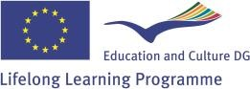
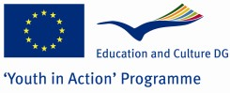

Name of the institution | University of Applied Sciences Marko Marulić in Knin (UASMMK)
Type | Public institution
Address | Kralja Petra Krešimira IV 30, 22300 KNIN
Webpage | www.veleknin.hr
Contact person | Sandra Mandinić, asistent
E-mail address | smandini@veleknin.hr
Short description of the institution | The UASMMK is a public, higher education institution, founded in June 2005 in accordance with the Bologna Process, incepted as an institution with the primary task of education of students through the professional studies (departments) (180 ECTS): Karst Agriculture (Plant Production and Animal Husbandry), Food Technology and Economics (Commercial Business and Small Business) and the Innovation Centre (IC) as the fourth department, designed as a technology park with educational agricultural and food processing pilot plant and accompanying laboratories, with the primary goal of practical and experimental work of students, as well as research and co-operation with businesses.
Field of interest for co-operation within the Erasmus programme | The UASMMK is interested in all co-operation activities under the Standard Erasmus University Charter (student and teaching and other staff mobility, Erasmus intensive language courses, multilateral projects, networks, accompanying measures and preparatory visits). Fields of interest include in a broader sense (but are not confined to) Agriculture, Food Science and Economics.
Letter of Intent (in form of an attachment written as a Word document) | Please find attached a Letter of Intent

