We are pleased to welcome you to the University of Applied Sciences Marko Marulic in Knin. Our University of Applied Sciences is a rather young institution, founded in 2005 by the Government of the Republic of Croatia, in order to establish and perform professional studies of Karst Agriculture, Business and Food Technology. Through this gesture, the Government has provided a great opportunity for the development of our City of Knin.
Based on that, our mission and vision are stated as follows:
The mission
The Mission of the University of Applied Sciences Marko Marulić in Knin is education of competent professionals in the field of Karst Agriculture, Food Technology and Commercial Business with Entrepreneurship prepared to face the challenges both of the national and international labour market and transfer of knowledge and technologies with the promotion of entrepreneurial spirit, academic excellence, ethical conduct, freedom and tolerance, as well as building a competitive economy both at the local and regional level.

The vision
The University of Applied Sciences Marko Marulić in Knin is an open, inclusive and sustainable institution recognisable by high culture of organisationl quality, modern approach to the teaching process and social responsibility, that takes pride in promotion of academic integrity, freedom and tolerance across the levels.

What are we?
As you can see, we provide a bond between higher education institutions, R&D and the local public sector. Hence, we perform professional studies that are needed for local economic development. Our professional studies are based upon traditional and characteristic activities for our region. We perform tree professional studies at the University and these are as follows:
- Karst Agriculture
- Food Technology
- Economics (Commercial Business with Entrepreneurship)
The professional studies at the University of Applied Sciences Marko Marulić are focused on the entire manufacturing sector of the Šibenik-Knin County. Our professors, associates and employees are highly recognised professionals in their fields and many of them are well known experts in Croatia. We have connected agricultural production, as plant and livestock production, with food production based on those products. Consequently, our students have been given an opportunity to become acquainted with the entire production process in accordance with their courses. Students of Commercial Business with Entrepreneurship may learn everything from product development to product placement, business strategies and sale strategies, among others.
The following table contains information concerning each study programme, the duration of study, ECTS credits and the qualification awarded after graduating from our University.
Undergraduate Professional Study of Commercial Business with Entrepreneurship | Commercial Business | 3 years / 6 semesters | Bachelor of Economics bacc. oec. | 180
 | Small  Business | 3 years / 6 semesters | Bachelor of Economics bacc. oec.
Undergraduate Professional Study of Karts Agriculture – Plant Production | Plant Production | 3 years / 6 semesters | Bachelor of Karst Agriculture bacc. agr. | 180
Undergraduate Professional Study of Karst Agriculture - Animal Husbandry | Animal Husbandry | 3 years / 6 semesters | Bachelor of Karst Agriculture bacc. agr.
Undergraduate Professional Study of Food Technology | Food Technology | 3 years / 6 semesters | Bachelor of Food Technology bacc.food tech. | 180
Specialist  Graduate Professional  Study of Economics and Normative Frame of Entrepreneurship | Economics and Normative Frame of Entrepreneurship | 2 years/  4 semesters | Professional Specialist of Economics  prof.spec.oec. | 120

Additional information about the study in Croatia is available on the following link:http://www.studyincroatia.hr/studying-incroatia/croatian-higher-education-system/degrees-and-studies.

Fra Lujo Marun Student Residence Hall in Knin
Students arriving to study at the University of Applied Sciences Marko Marulić in Knin within Erasmus + Programme are provided the opportunity of organised accommodation in Fra Lujo Marun Student Residence Hall.
Fra Lujo Marun Student Residence Hall comprises of two main facilities, buildings A and B and an auxiliary facility, i.e. the boiler room. Each building comprises of the ground floor, the first floor and the attic.
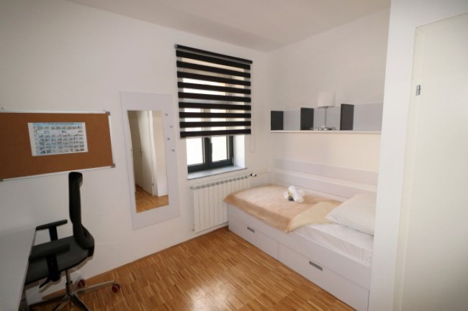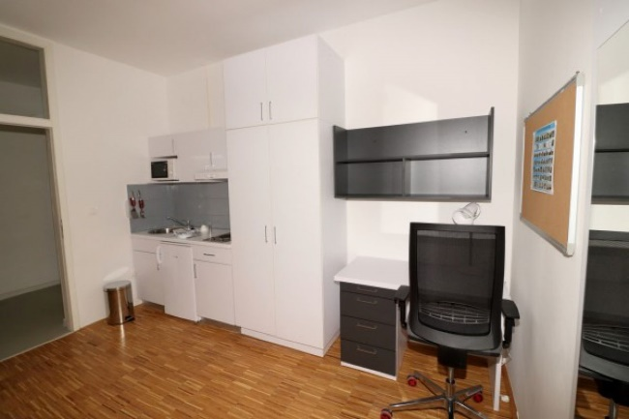
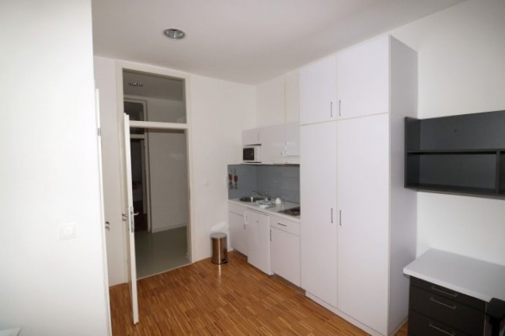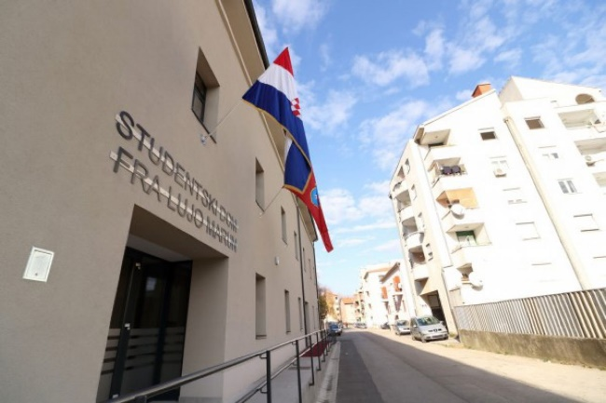
Between buildings A and B there are paths, green spaces and an open stage, while behind the building B there is a parking area in which the boiler room is also located.
The building A includes the offices of the University, common rooms, a large multipurpose hall and 5 suites in the attic, each of which comprises of a living room, a bedroom and sanitary fixtures, each covering an area of around 40 m². Moreover, the building A comprises of newly opened premises of the National Library of Knin.
The building B comprises of 53 student rooms, which in total provides accommodation for 78 students, 28 of which are single rooms with a kitchenette and a bathroom (2 of which are adapted to meet the requirements of the disabled) and 25 double rooms with a bathroom and a refrigerator. There is a kitchenette on each floor and a day room intended to meet student requirements – as a socialising zone. The ground floor of the building B comprises of a common room that includes washing and drying machines.
Accommodation fees of Erasmus + students have been determined upon the Decision on Accommodation Fees at Fra Lujo Marun Student Residence Hall of the University of Applied Sciences Marko Marulić in Knin, totalling as follows:
- a single room HRK800.00 (monthly)
- a double room HRK600.00 (monthly)
- a single room with a separate bathroom HRK1,000.00 (monthly)

The University of Applied Sciences Marko Marulic is located in Knin, a small city in Dalmatia. Dalmatia is a southern Croatian region, known as a tourist destination. Knin is a beautiful, small city with great historical and cultural heritage. It was mentioned for the first time in the 10th century and since then it has been deemed controversial among many local and foreign rulers. All the turmoil that ensued has resulted in a wide range of historical and cultural monuments in the city and its surroundings. The most famous historical and cultural monuments are the Knin fortress, Burnum (an ancient Roman military camp) and the towers of the Croatian kings.
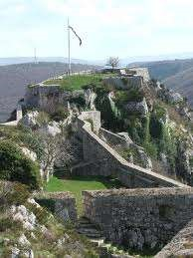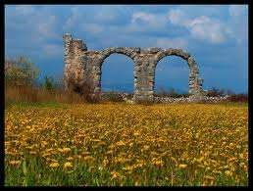
Knin fortress Burnum
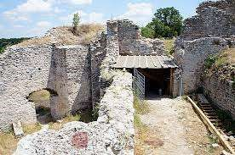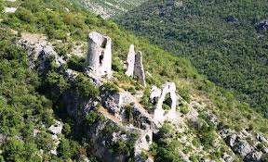
Nečven town Trošenj town
Moreover, Knin and its surroundings abound in natural beauty and the environment has been preserved. In Knin there are seven rivers and among them the Krka River is the biggest. The Krka National Park starts in Knin and follows the course of the Krka River to the Adriatic Sea. The Krka River is one of the most beautiful rivers in Croatia with hundreds of waterfalls. As you can imagine, the waters of the Krka River make an ideal place for refreshment on hot summer days.
Knin is located under Dinara Mountain, whose peak is the highest peak in Croatia and it is 1831 meters above sea level. Dinara Mountain is an ideal place for a getaway from the city rush and stressful lifestyle to name a few. You can reach it on foot, by a mountain bike, on horseback or by cross country cars.
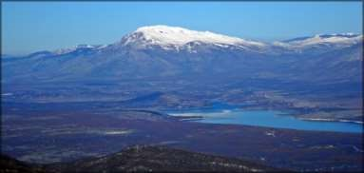
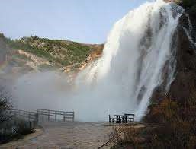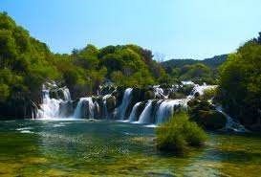

Dinara

Mountain and Peruča Lake

Krčić Waterfalls Waterfalls on the River Krka
During the summer many cultural events are held. The most famous are the Days of Zvonimir where you can gain insight into the medieval lifestyle through a re-enactment of life in the royal castle. Burnum Nights will give you an insight into the Roman life, due to a reconstruction of some famous Roman games inside the original Roman amphitheater.

Scenes from Burnum Nights
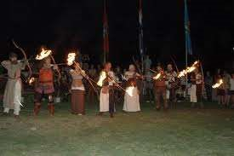

Scenes from the Days of Zvonimir
As you can see, Knin is not yet another "University city", it is more than that. Not only will you get high quality professional education, but you will also get an insight into a unique way of life. If you decide to study at our University, you will have an opportunity to experience life in symbiosis with nature, traditional knowledge, historical and cultural heritage and the modern way of life.

The University of Applied Sciences Marko Marulic is located in Knin, in the northern part of Dalmatia. Knin is connected with other parts of Croatia by several state and regional roads and by the railways from Zagreb to Split. You can also reach us by bus, car and train from Zagreb (the capital of Croatia), Split, Zadar and Šibenik. In addition, you can fly to Split or Zadar and then come to Knin. The University is in the centre of Knin. Since Knin is a very small city, you can go everywhere on foot. The University Library, student dormitory and student restaurant are next to the University, so you have everything within reach. In the following map of Croatia you can see where we are and you have also been provided the link to the interactive map made by the Knin Tourist Board, on the website.
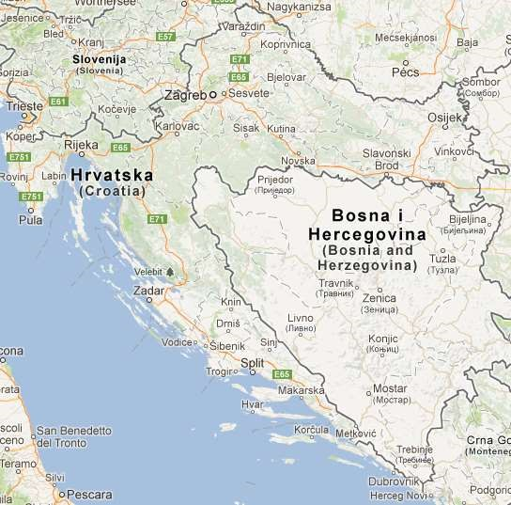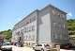
KNIN

Additional information is available on: http://www.tz-knin.hr/index.php/o-knini/kako-do-knina
We hope that you will find our University very interesting for your study and that you are going to visit us. As we have said before, we are a small University in a small city, yet we are abounding with distinguished and respected professors, high quality study programmes and are involved in practical work throughout the study. Our city may be small by the number of its residents or space, but it is big in terms of its heart, the kindness of the people, the preserved environment, as well as its historical and cultural heritage.
